

**Capstone Project**

**(University DataBase Management System)**

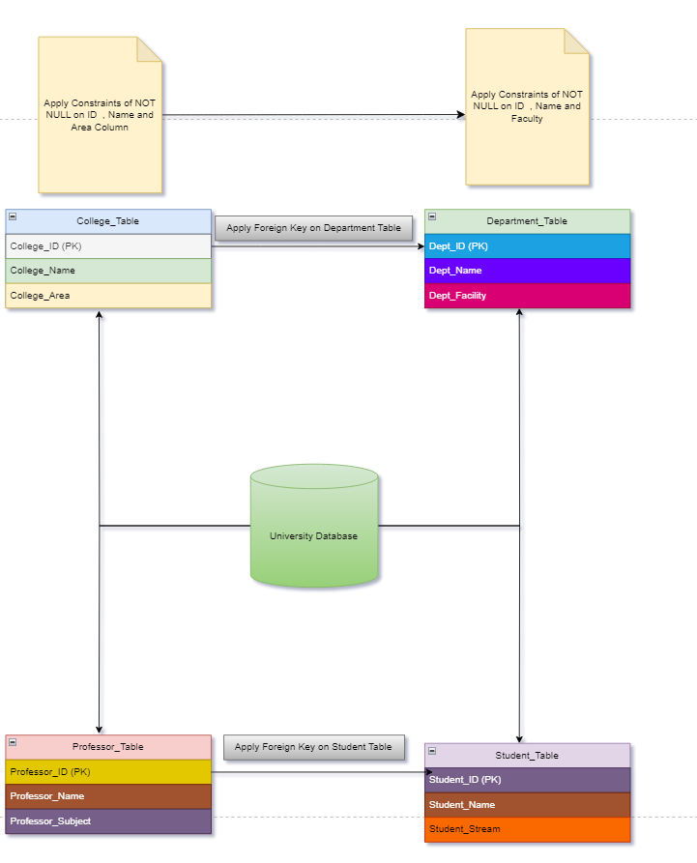

University Database Management System is one of the Fundamental and Intermediate level SQL project

Here in this Project you have to create an efficient DBMS for the any University .

Inorder to create this system Perform the following task:-

**Task 1:-**

1.Create University Database give any University name you want

Answer- CREATE DATABASE University

2. Under this University Create four tables and each table should have following three Column named as:-

A. College_Table

College_ID(PK)

College_Name

College_Area

B. Department_Table

Dept_ID(PK)

Dept_Name

Dept_Facility

C. Professor_Table

Professor_ID(PK)

Professor_Name

Professor_Subject

D. Student_Table

Student_ID(PK)

Student_Name

Student_Stream

Answer- CREATE TABLE College_Table (

College_ID INT PRIMARY KEY,

College_Name VARCHAR(255),

College_Area VARCHAR(255)

)

CREATE TABLE Department_Table (

Dept_ID INT PRIMARY KEY,

Dept_Name VARCHAR(255),

Dept_Facility VARCHAR(255))

-- Task 2: Create Professor_Table

CREATE TABLE Professor_Table (

Professor_ID INT PRIMARY KEY,

Professor_Name VARCHAR(255),

Professor_Subject VARCHAR(255))

-- Task 2: Create Student_Table

CREATE TABLE Student_Table (

Student_ID INT PRIMARY KEY,

Student_Name VARCHAR(255),

Student_Stream VARCHAR(255))

3. Apply foreign key on Department key from College_table

Answer- ALTER TABLE Department_Table

ADD CONSTRAINT College_ID

FOREIGN KEY (College_ID)

REFERENCES College_Table (College_Id)

4. Apply foreign Key on Student_Table from Professor_Table

Answer-

ALTER TABLE Student_Table

ADD CONSTRAINT Professor_ID

FOREIGN KEY (Professor_ID)

REFERENCES Professor_Table(Professor_ID)

5. Insert atleast 10 Records in each table

Answer- - Task 5: Insert records into College_Table

INSERT INTO College_Table(College_Name, College_Area) VALUES

('Engineering College', 'Science and Technology Park'),

('Arts College', 'Downtown Area'),

('Business College', 'Financial District'),

('Medical College', 'Hospital Campus')

-- Task 5: Insert records into Department_Table

INSERT INTO Department_Table (Dept_Name, Dept_Facility, College_ID) VALUES

('Computer Science', 'Computer Lab', 1),

('Mechanical Engineering', 'Engineering Lab', 1),

('English Literature', 'Library', 2),

('Economics', 'Research Center', 2),

('Finance', 'Trading Floor', 3),

('Marketing', 'Marketing Lab', 3),

('Internal Medicine', 'Hospital Ward', 4),

('Pediatrics', 'Pediatric Ward', 4)

-- Task 5: Insert records into Professor_Table

INSERT INTO Professor_Table (Professor_Name, Professor_Subject, Dept_ID) VALUES

('Dr. Smith', 'Computer Science', 1),

('Prof. Johnson', 'Mechanical Engineering', 2),

('Dr. Adams', 'English Literature', 3),

('Prof. Brown', 'Economics', 4),

('Dr. Davis', 'Finance', 5),

('Prof. Wilson', 'Marketing', 6),

('Dr. Miller', 'Internal Medicine', 7),

('Prof. Taylor', 'Pediatrics', 8)

-- Task 5: Insert records into Student_Table

INSERT INTO Student (Student_Name, Student_Stream, Professor_ID) VALUES

('John Doe', 'Computer Science', 1),

('Jane Smith', 'Mechanical Engineering', 2),

('David Lee', 'English Literature', 3),

('Emily Johnson', 'Economics', 4),

('Michael Brown', 'Finance', 5),

('Sophia Davis', 'Marketing', 6),

('Emma Wilson', 'Internal Medicine', 7),

('William Taylor', 'Pediatrics', 8)

**Task 2:-**

1. Give the information of College_ID and College_name from College_Table

Answer- SELECT College_ID, College_Name

FROM College_Table

1. Show Top 5 rows from Student table.

Answer- SELECT TOP 5 *

FROM Student_Table

1. What is the name of professor whose ID is 5

Answer- SELECT Professor_Name

FROM Professor_Table

WHERE Professor_ID = 5

1. Convert the name of the Professor into Upper case

Answer SELECT UPPER(Professor_Name) AS Professor_Name_Upper

FROM Professor_Table

1. Show me the names of those students whose name is start with a

Answer- SELECT Student_Name

FROM Student_Table

WHERE Student_Name LIKE 'a%'

1. Give the name of those colleges whose end with a

Answer- SELECT College_Name

FROM College_Table

WHERE College_Name LIKE '%a'

1. Add one Salary Column in Professor_Table

Answer- ALTER TABLE Professor_Table

ADD Salary DECIMAL(10,2)

1. Add one Contact Column in Student_table

Answer- ALTER TABLE Student_Table

ADD Contact VARCHAR(Max)

1. Find the total Salary of Professor

Answer- SELECT SUM(Salary) AS Total_Salary

FROM Professor_Table

1. Change datatype of any one column of any one Table

Answer- ALTER TABLE Professor_Table

ALTER COLUMN Salary DECIMAL(10, 2)

**Task 3:-**

1. Show first 5 records from Students table and Professor table Combine

Amswer- (

SELECT Student_ID, Student_Name, Student_Stream, NULL AS Professor_ID, NULL AS Professor_Name, NULL AS Professor_Subject, NULL AS Salary, NULL AS Contact

FROM Student_Table

LIMIT 5

)

UNION ALL

(

SELECT NULL AS Student_ID, NULL AS Student_Name, NULL AS Student_Stream, Professor_ID, Professor_Name, Professor_Subject, Salary, NULL AS Contact

FROM Professor_Table

LIMIT 5

)

1. Apply Inner join on all 4 tables together

Answer-

SELECT *

FROM College_Table AS

INNER JOIN Department_Table AS Department_table ON College_Table.College_ID = Department_table.College_ID

INNER JOIN Professor_Table AS Professor_Table ON Department_table.Dept_ID = Professor_Table.Dept_ID

INNER JOIN Student_Table AS Student_Table ON Professor_Table.Professor_ID = Student_Table.Professor_ID

1. Show Some null values from Department table and Professor table.

Answer- -- Show null values from Department table

SELECT *

FROM College_Table AS

LEFT JOIN Department_Table AS Department_Table ON College_Table.College_ID = Department_Table.College_ID

WHERE Department_Table.Dept_ID IS NULL

-- Show null values from Professor table

SELECT *

FROM Department_Table AS

LEFT JOIN Professor_Table AS Professor_Table ON Department_Table.Dept_ID = Professor_Table.Dept_ID

WHERE Professor_Table.Professor_ID IS NULL

1. Create a View from College Table and give those records whose college name starts with C

Answer- CREATE VIEW College_StartsWith_College_View AS

SELECT *

FROM College_Table

WHERE College_Name LIKE 'C%'

1. Create Stored Procedure of Professor table whatever customer ID will be given by user it should show whole records of it.

Answer CREATE PROCEDURE GetProfessorByID

@ProfessorID INT

AS

BEGIN

SELECT *

FROM Professor_Table

WHERE Professor_ID = @ProfessorID

END

1. Rename the College_Table to College_Tables_Data .

Answer- EXEC sp_rename 'College_Table', 'College_Tables_Data'